## Assignment 1

**Due Date:** 3/10/2023

**Time:** 23.55

**Please note:**

This is an individual assignment

No late submissions are accepted.

**Question #1 Static Backward Slicing**

1. Create a static PDG for the program below

|  |  |
| --- | --- |
| 1. Cin >> B; 2. Cin >> X; 3. A=x+b; 4. While (A<(x+B))  {  1. x=a; 2. If (a>b)   {   1. b=10+A+B;   }   1. Else   {   1. x= a-1;   }   1. x--; 2. A=A-B-X;   }   1. If b < x)   {   1. X=10;   }   1. Cout <<a; 2. Cout <<b; 3. Cout <<x; |  |

1. **Compute a static slice for the following variables.**

**Compute Slice (B,15)= { }**

**Compute Slice S(X,16) = { }**

1. Compute a static forward slice

for statement 9 => Static slice S(9) ={ }

for statement 13 => Static slice s(13) ={ }

Hint: There is no need to create a new PDG, you can reuse the one from question A)

Question #2

Please use the Program shown on the left and complete the program dependencies in the table–

|  |  |  |  |  |  |  |  |  |  |  |  |  |  |  |  |  |  |  |  |  |  |  |  |  |  |  |  |  |  |  |  |  |  |  |  |  |  |  |  |  |  |  |  |  |  |  |  |
| --- | --- | --- | --- | --- | --- | --- | --- | --- | --- | --- | --- | --- | --- | --- | --- | --- | --- | --- | --- | --- | --- | --- | --- | --- | --- | --- | --- | --- | --- | --- | --- | --- | --- | --- | --- | --- | --- | --- | --- | --- | --- | --- | --- | --- | --- | --- | --- |
| 1. Y =10 2. If (Y) 3. Y=Y+1; | | |  |  |  |  |  | | --- | --- | --- | --- | --- | |  | Is **data** dependent on | | | | | **Node** |  | 1 | 2 | 3 | | 1 |  |  |  | | 2 | X |  |  | | 3 | X |  |  | | |  |  |  |  |  | | --- | --- | --- | --- | --- | |  | Is **control** dependent on | | | | | **Node** |  | 1 | 2 | 3 | | 1 |  |  |  | | 2 |  |  |  | | 3 |  | X |  | |
| 1. Cin >> B; 2. Cin >> X; 3. A=x+b; 4. While (A<(x+B))   {   1. x=B+X; 2. If (a>(b~~+C~~))   {   1. b=10+A+B;   }   1. Else   {   1. x= 10;   }   1. x--; 2. A=A-B-X;   }   1. Cout <<a; 2. Cout <<b; 3. COUT <<X; | |  | | --- | |  | | **Node** |  | 1 | 2 | 3 | 4 | 5 | 6 | 7 | 8 | 9 | 10 | 11 | 12 | 13 | 14 | | 1 |  |  |  |  |  |  |  |  |  |  |  |  |  |  | | 2 |  |  |  |  |  |  |  |  |  |  |  |  |  |  | | 3 |  |  |  |  |  |  |  |  |  |  |  |  |  |  | | 4 |  |  |  |  |  |  |  |  |  |  |  |  |  |  | | 5 |  |  |  |  |  |  |  |  |  |  |  |  |  |  | | 6 |  |  |  |  |  |  |  |  |  |  |  |  |  |  | | 7 |  |  |  |  |  |  |  |  |  |  |  |  |  |  | | 8 |  |  |  |  |  |  |  |  |  |  |  |  |  |  | | 9 |  |  |  |  |  |  |  |  |  |  |  |  |  |  | | 10 |  |  |  |  |  |  |  |  |  |  |  |  |  |  | | 11 |  |  |  |  |  |  |  |  |  |  |  |  |  |  | | 12 |  |  |  |  |  |  |  |  |  |  |  |  |  |  | | 13 |  |  |  |  |  |  |  |  |  |  |  |  |  |  | | 14 |  |  |  |  |  |  |  |  |  |  |  |  |  |  |   **Data Dependencies**  **Control Dependencies**   |  | | --- | |  | |  |  | 1 | 2 | 3 | 4 | 5 | 6 | 7 | 8 | 9 | 10 | 11 | 12 | 13 | 14 | | **Node** | 1 |  |  |  |  |  |  |  |  |  |  |  |  |  |  | | 2 |  |  |  |  |  |  |  |  |  |  |  |  |  |  | | 3 |  |  |  |  |  |  |  |  |  |  |  |  |  |  | | 4 |  |  |  |  |  |  |  |  |  |  |  |  |  |  | | 5 |  |  |  |  |  |  |  |  |  |  |  |  |  |  | | 6 |  |  |  |  |  |  |  |  |  |  |  |  |  |  | | 7 |  |  |  |  |  |  |  |  |  |  |  |  |  |  | | 8 |  |  |  |  |  |  |  |  |  |  |  |  |  |  | | 9 |  |  |  |  |  |  |  |  |  |  |  |  |  |  | | 10 |  |  |  |  |  |  |  |  |  |  |  |  |  |  | | 11 |  |  |  |  |  |  |  |  |  |  |  |  |  |  | | 12 |  |  |  |  |  |  |  |  |  |  |  |  |  |  | | 13 |  |  |  |  |  |  |  |  |  |  |  |  |  |  | | 14 |  |  |  |  |  |  |  |  |  |  |  |  |  |  | | | | |

**Question #3**

Given is the following program and PDG – identify all the problems in this PDG (wrong/missing dependencies)

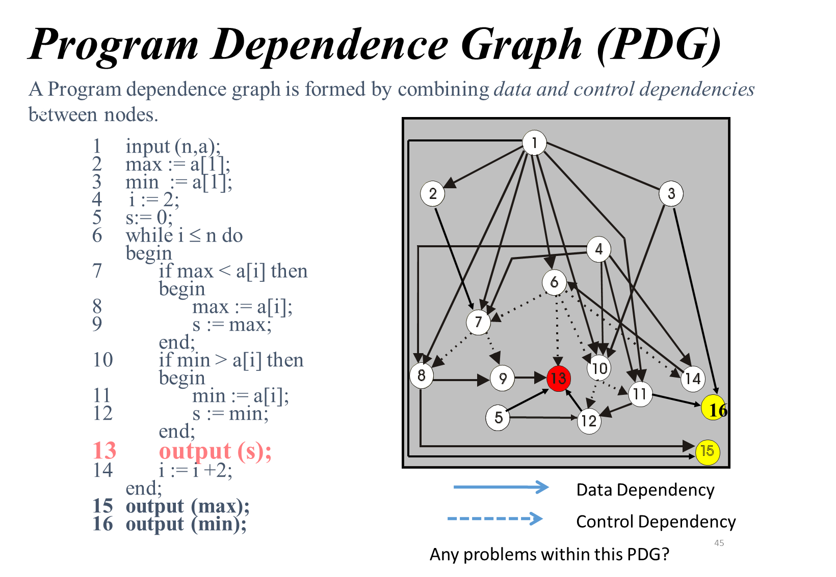

|  |  |
| --- | --- |
| **Data dependencies:** | **Missing:**  **Should be removed:** |
| **Control dependencies:** | **Missing:**  **Should be removed:** |

**Question #4**

In a recent department meeting your new boss made the following statement. I just read a research paper which discussed software aging and I am not sure if the claims in the paper are correct. In their paper the authors state that the cause for software aging is: (1.) ignorant surgery – that is modifications being performed to a software product by people who are not necessarily skilled/trained enough to perform such software changes; as well as by (2.) too much movement, that is, software is changed to remove technical debt.

Your boss is asking if you agree/disagree with the two claims made in the paper. Clearly state if you agree/disagree with each claim (1.) and (2.) and briefly justify your decisions (max. 50 words)

**Question #5**

You were reading in an article the following statement: The major objective of perfective maintenance is to reduce technical debt in a software system.

Is the above statement, correct? Clearly indicate if you agree/disagree. Briefly justify your answer (1-2 sentences)